Design Document ”WarFactory”

# General Game Overview

This is a game combining Factorio (without belts!) and Age Of Empire. The complexity of the game will stem from supplying defence and combating units with the resources needed to wage war, while at the same time providing for the civilian population.

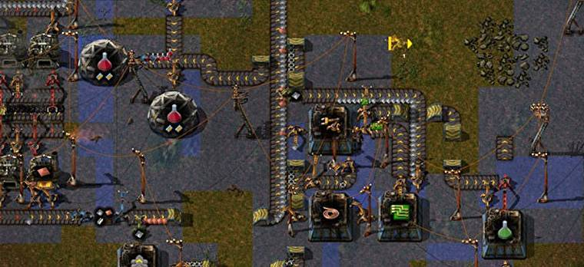Factorio

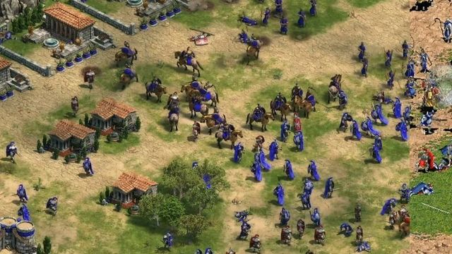Age of Empire

# Game Mechanics

## Production

### Production of Raw Resources

### Production of Refined Resources

## Transport

### Vehicles

### Roads

### Train

## Combat

# Game Map

# Civilian Units

# Civilian Buildings

# Military Units

# Military Buildings